**Section 26 done: 1/1 Bonus: Building the Burger CSS**  
**Building the Burger CSS Code**  
* This Burger will use HTML and CSS, no JavaScript.  
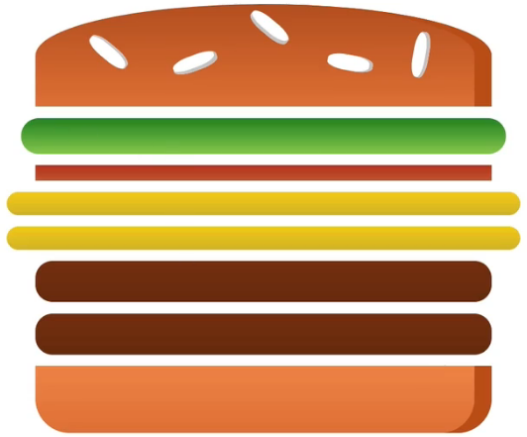  
* I’ll have a wrapping DIV as a container for the burger.  
* In there I’ll have a DIV for each ingredient.  
* That is the idea, having all these DIV ingredients sitting next to each other, styling them with CSS.  
* I’m giving .box some basic styles and you can always adjust this later, tweak width/height later.  
 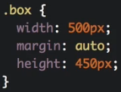  
* Now the .bread-top should be a box with round corners on the top left and right corner so that we have a straigth line at the bottom, clear edges on the sides on the bottom corners but then this rounded look at the top.  
* In CSS we obviously always work with boxes, and all these ingredients are nothing else than boxes with some rounded edges, some round corners.  
* For color I actually want to use a linear-gradient to give this also some 3D look so that we don’t have the same monotone color for the entire bread. We use linear-gradient on the background. It takes all the different shades you want to transition through.  
* border-radius: top-left top-right bottom-right bottom-left. We can use 50% to make it very round.  
* box-shadow to give it a 3D look, but not one which goes outside of the bread but an inset shadow so which falls onto the bread.  
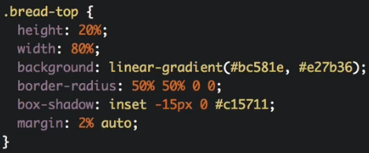 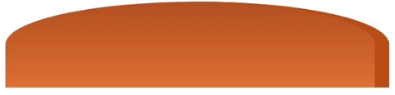  
* We’ll add the seeds later.  
* Bread had 80% width so let’s give a salad 90% width, and it should be a bit thinner so 7% vs 20%.  
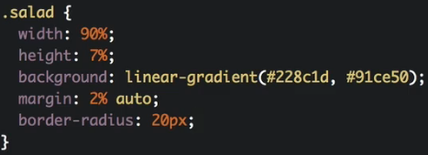 

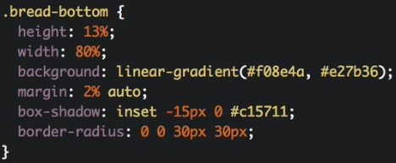 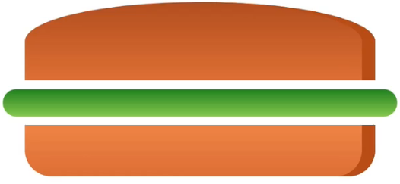  
* Now if I duplicate the <div class=”salad”></div>, we got 2 salads in there so it’s reusable.  
* Let’s add more ingredients.  
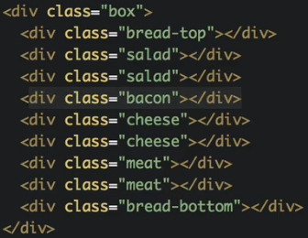  
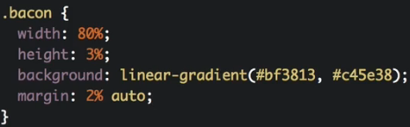 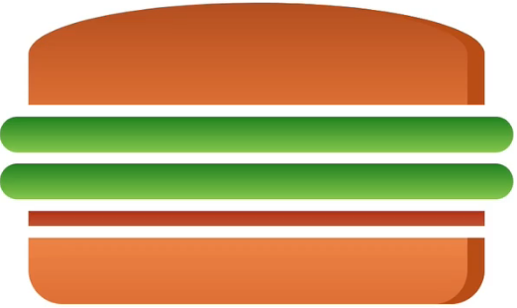

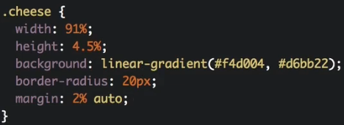 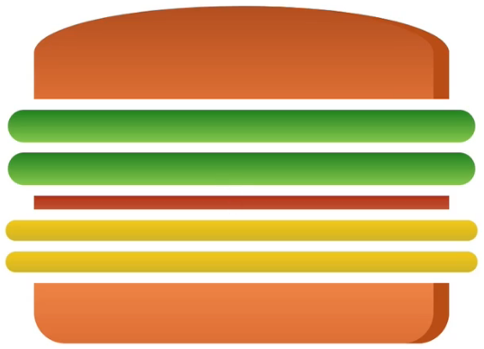

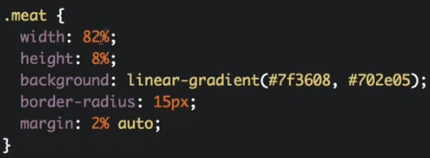 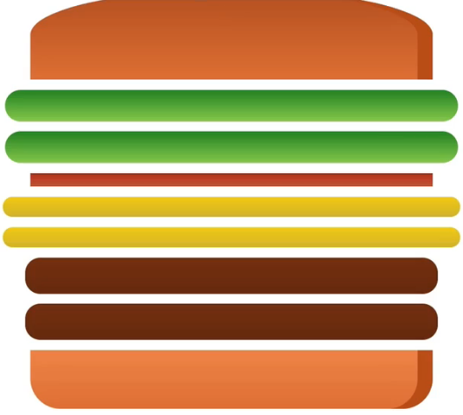  
* Now this is the burger in general but the seeds are missing.  
* The seeds are actually a bit more work to have them look good.  
* I’m going to have .seeds and .seeds2 nested inside the .bread-top. I of course want to have more than 1 seed and I will take advantage of a CSS feature to actually convert each DIV here into up to 3 seeds if I want to but I can’t go above these 3 seeds easily.  
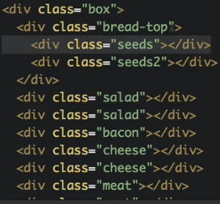  
* .seeds - I want to position it inside the .bread-top and I want to be able to use this like an absolute viewport to really position the seeds as I want. Now for absolute referring to my outer DIV, I need to give my .bread-top the position: relative - then the next absolute position will refer to this.  
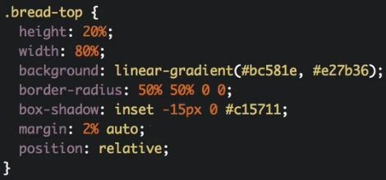  
* I want to rotate the seed a little bit so I’ll use the transform: rotate(-20deg).  
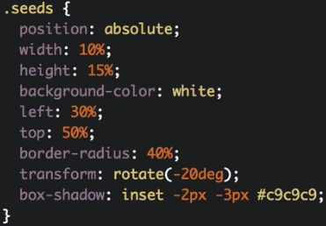 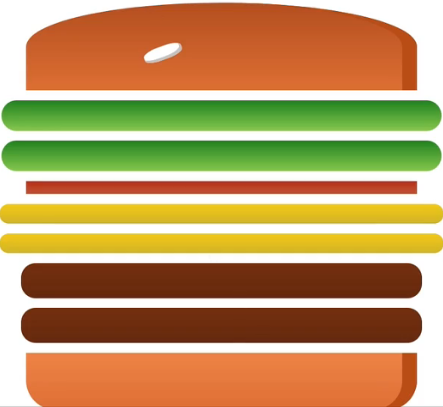  
* I want to have more than 1 so I’m gonna use a pseudo-selector.  
=> .seeds:after {} - this allows me to create a new element which is displayed after this .seeds element. The content: “” is required to display something. Width 100% will now refer to the .seeds class, same for height. Now this left position also refers to the other seed so I’ll use -170% to move it to the left -170% of the width of the previous seed and let’s move it to the top by -260%, this’ll move it up by 2.6 times height of this original seed. Now I want to rotate this differently. If I give it 0deg, it won’t change because now the default rotation is the rotation of the element I positioned it after so if I gave it 20deg, it would be straight again. Let’s give it 60deg.  
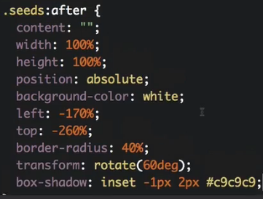 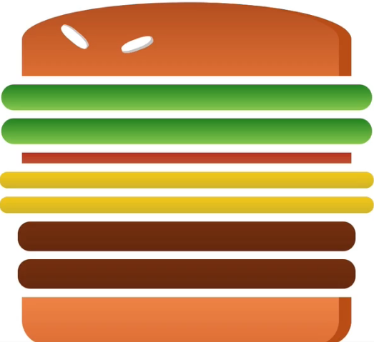  
* Now I’ll add a 3rd one.  
* For that I’ll use the other pseudo-selector: before.  
* The position changes, I want to move it to the right, so I’ll use left: 180% and then I want to push this up not as high so I’ll use -50% to move it up. I’ll adjust the box-shadow to come from an opposite direction with -3px for second value, now it’s coming from the bottom left.  
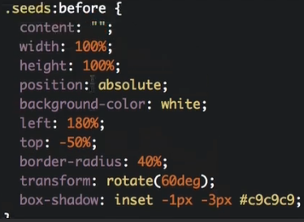 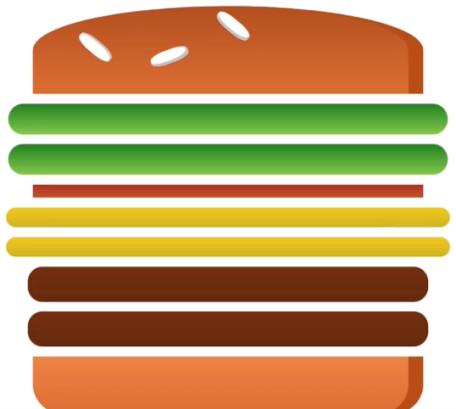  
* Now let’s work on the other seeds, .seeds2.  
* I’ll just copy the code from .seeds and let’s see what we need to adjust.  
* The positioning has to change, I’m going to push this farther to the right with left: 64% and I’ll leave top: 50%. I want to rotate it differently, let’s say 10deg to have a slight rotation to the right. And I want to adjust the box-shadow to -3px -0.  
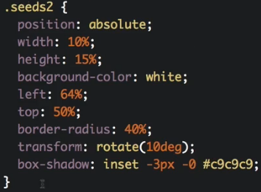  
* Now let’s use the after pseudo-selector. Let’s add content: “” so that we can see something. Let’s move it farther to the right by pushing this left: 150% away from left and for top let’s use -130% to move it up a little bit. Let me rotate it by 90deg to really have it be rotated totally differently. And I’ll adjust the box-shadow to use 1px 3px, to come from the right like this.  
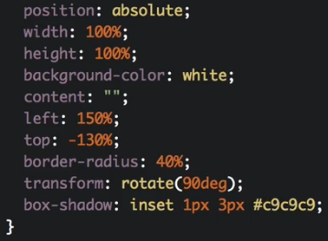 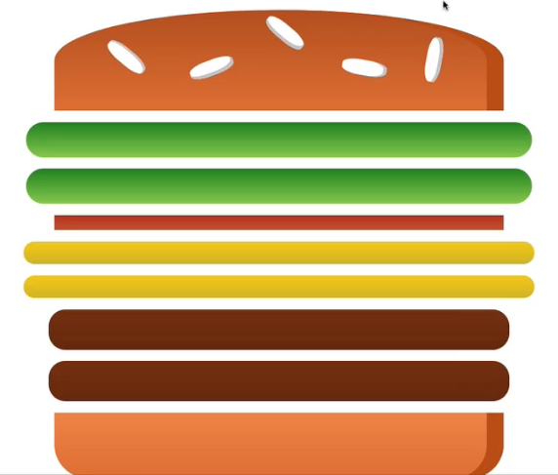  
* Now with that, I got this seed in place and I’d say this looks like a nice burger.  
* This is the burger we built in the React app in the Burger Builder in this React course.  
* I hope you enjoyed learning how you can build elements like this with just CSS, this doesn’t use any images, nothing like that, it’s just CSS and as you saw, not even that many CSS properties we’re using.